

CROSS-UTILITY SMART CAMPUS RESOURCE MONITOR:
INTEGRATED ENERGY COMPETITION AND WATER LEAKAGE DETECTION

A Capstone Project Report submitted in partial fulfilment of the requirements for the Course of

CSA0925 – Programming in Java

to the award of the degree of

BACHELOR OF ENGINEERING / BACHELOR OF TECHNOLOGY IN
INFORMATION TECHNOLOGY

Submitted by
I. MD IMTHIAZ (192521360)

Under the Supervision of
Dr. C. Sivasankar
SIMATS ENGINEERING
Saveetha Institute of Medical and Technical Sciences Chennai-602105

SEPTEMBER 2026

SIMATS ENGINEERING
Saveetha Institute of Medical and Technical Sciences Chennai-602105

BONAFIDE CERTIFICATE

This is to certify that the Capstone Project entitled “CROSS-UTILITY SMART CAMPUS RESOURCE MONITOR: INTEGRATED ENERGY COMPETITION AND WATER LEAKAGE DETECTION” has been carried out by I. MD IMTHIAZ (192521360) under the supervision of Dr. C. Sivasankar and is submitted in partial fulfilment of the requirements for the current semester of the B.Tech Information Technology program at Saveetha Institute of Medical and Technical Sciences, Chennai.

COURSE COORDINATOR COURSE FACULTY
Dr. G. Charlyn Pushpa Latha, Dr. C. Sivasankar
Professor Professor
Department of CSE Department of CSE
SIMATS Engineering, SIMATS Engineering,
SIMATS, Chennai – 602105. SIMATS, Chennai – 602105.

SIMATS ENGINEERING
Saveetha Institute of Medical and Technical Sciences Chennai-602105

DECLARATION

We, [I. MD IMTHIAZ] of the [Information Technology], SIMATS Engineering, Saveetha Institute of Medical and Technical Sciences, Chennai, hereby declare that the Capstone Project Work entitled “[CROSS-UTILITY SMART CAMPUS RESOURCE MONITOR: INTEGRATED ENERGY COMPETITION AND WATER LEAKAGE DETECTION]” is the result of our own bonafide efforts. To the best of our knowledge, the work presented herein is original, accurate, and has been carried out in accordance with the principles of engineering ethics and academic integrity. All sources, references, data, and other materials used in the project have been appropriately acknowledged. We further declare that the data, results, analysis, and findings presented in this report have not been fabricated, falsified, or manipulated. Any external tools, software, datasets, computational resources, or AI-assisted tools used during the project have been appropriately disclosed. We confirm that all applicable ethical, academic, institutional, and professional requirements have been duly followed throughout the planning, execution, analysis, and documentation of the project.

Place: Thandalam
Date: 08-09-2026

Signature of the Students with Names

SIMATS ENGINEERING
Saveetha Institute of Medical and Technical Sciences Chennai-602105

Individual Contribution Statement

Student Name / Register No. | Specific  Responsibilities | Design & Development Contribution | Testing & Analysis  Contribution | Report Contribution | Approx.  Contribution (%)
I. Md Imthiaz | Module 2 – Leak Detection & Anomaly Alert | Primary individual responsibility for Module 2; supported water-usage pattern analysis, anomaly identification and alert workflow design/implementation | Tested normal and abnormal water-usage cases, anomaly flags, alert generation and module integration. | Module 2 documentation, design explanation, testing and individual reflection. | 50%
2.G SAI DEEPAK | Module 1 – Utility Monitoring | Primary responsibility for Module 1; utility monitoring workflow for electricity and water information. | Testing of utility input, validation and monitoring outputs. | Module 1 documentation and related technical content. | 50%
Total |  |  |  |  | 100%

ABSTRACT

The Cross-Utility Smart Campus Resource Monitor: Integrated Energy Competition and Water Leakage Detection is a smart campus resource management system developed to monitor utility consumption, identify abnormal usage patterns, and support efficient resource utilization. The system integrates a web-based frontend developed using HTML, CSS, and JavaScript with a backend implemented using Java 21 and Spring Boot 3.3.5. The project is organized into utility monitoring, leak detection and anomaly alert, and gamified energy competition functionalities.
The major individual contribution presented in this report is Module 2: Leak Detection & Anomaly Alert. This module focuses on analysing water-usage data and identifying significant deviations from expected consumption patterns. The module processes recorded water-consumption values, compares actual usage against expected usage conditions, and identifies abnormal consumption that may indicate a possible water leakage or excessive usage. When an abnormal condition is detected, the system generates an appropriate anomaly flag and alert so that the issue can be identified and addressed promptly.
The implemented workflow consists of water-usage data processing, expected-usage comparison, anomaly identification, alert generation, and result presentation. Different consumption conditions are considered to distinguish normal water usage from potentially abnormal usage. The module is designed to provide clear alerts for conditions such as high water usage, water leakage indications, and abnormal consumption. This supports timely identification of resource wastage and improves the overall monitoring capability of the campus resource management system.
The development of this module provided practical experience in Java programming, Spring Boot application development, data processing, conditional analysis, anomaly detection logic, alert generation, testing, and module-level integration. Testing was performed using normal and abnormal water-usage scenarios to verify the correctness of anomaly identification and alert generation. The module demonstrates how software-based monitoring and rule-driven anomaly detection can be applied to support sustainable water-resource management in a smart campus environment.
Keywords: Smart Campus, Java, Spring Boot, Water Usage Monitoring, Leak Detection, Anomaly Detection, Alert Generation, Resource Management.

TABLE OF CONTENTS

Sl.  No | Title | Page  No
i | CERTIFICATE FROM THE SUPERVISOR | ii
ii | DECLARATION BY THE CANDIDATE | iii
Iii | INDIVIDUAL CONTRIBUTION STATEMENT | iv
iv | ABSTRACT | v
v | LIST OF FIGURES | vi
vi | LIST OF TABLES | vii
vii | LIST OF ABBREVIATIONS | viii
1 | CHAPTER 1: Introduction
2 | CHAPTER 2: Literature Review
3 | CHAPTER 3: Engineering Design & Trade-offs, Sustainability,  Ethics, Safety, Risk & Security
4 | CHAPTER 4: Implementation, Testing & Results, Project  Management
5 | CHAPTER 5: Conclusion & Reflection
 | References
 | Appendices

LIST OF FIGURES

Figure No. | Figure Name | Page No.
Figure 3.1 | Proposed System Architecture | 8
Figure 3.2 | System Development Workflow | 9
Figure 3.3 | Module 2 – Leak Detection & Anomaly Alert Workflow | 9
Figure 3.4 | Use Case Diagram | 10
Figure 3.5 | Sequence Diagram | 10
Figure 3.6 | Entity/Data Relationship Diagram | 11
Figure 4.1 | Login Interface | 14
Figure 4.2 | Dashboard Interface | 15
Figure 4.3 | Electricity Usage Monitoring Interface | 15
Figure 4.4 | Alerts Management Interface | 16
Figure 4.5 | Hostel Energy-Efficiency Ranking | 17

LIST OF TABLES

Table No. | Table Name | Page No.
Table 1.1 | Project Objectives | 3
Table 2.1 | Existing Approach Review | 4
Table 2.2 | Comparative Analysis | 5
Table 3.1 | Stakeholder / User Requirements | 6
Table 3.2 | Functional and Non-Functional Requirements | 7
Table 3.3 | Constraints and Applicable Standards | 7
Table 3.4 | Design Specifications | 8
Table 3.5 | Alternative Solution Evaluation | 8
Table 3.6 | Trade-off Analysis | 11
Table 3.7 | Sustainability, Ethics, Safety and Security | 12
Table 3.8 | Risk Register | 12
Table 4.1 | Development Resources | 13
Table 4.2 | Test Plan and Verification | 19
Table 4.3 | Prototype Result Evidence | 20
Table 4.4 | Objective Achievement | 21
Table 4.5 | Project Roles and Contributions | 28
Table 4.6 | Project Cost Summary | 29

LIST OF ABBREVIATIONS / SYMBOLS

Symbol | Description | Unit
API | Application Programming Interface | —
CSS | Cascading Style Sheets | —
HTML | HyperText Markup Language | —
HTTP | HyperText Transfer Protocol | —
IoT | Internet of Things | —
JS | JavaScript | —
REST | Representational State Transfer | —
UML | Unified Modeling Language | —
UI | User Interface | —
kWh | Kilowatt-hour | kWh
L | Litre | L

CHAPTER 1

INTRODUCTION AND ENGINEERING PROBLEM

  - Background
Efficient management of essential resources is an important requirement in a modern smart campus environment. Educational institutions consume significant quantities of electricity and water across hostels, academic buildings, laboratories, offices, and other facilities. Without continuous monitoring, abnormal consumption and resource wastage may remain unnoticed for extended periods. Water leakage is one such problem that can result in unnecessary water loss, increased consumption, and inefficient utilization of campus resources.
The Cross-Utility Smart Campus Resource Monitor: Integrated Energy Competition and Water Leakage Detection is developed as a smart resource-management solution for monitoring campus utility consumption and identifying abnormal usage conditions. The system combines a web-based frontend developed using HTML, CSS, and JavaScript with a backend developed using Java 21 and Spring Boot 3.3.5. The system is designed to process utility-related information and present useful monitoring and alert information to support better resource management.
The individual technical focus of this report is Module 2: Leak Detection & Anomaly Alert. This module concentrates on water-usage analysis and the identification of abnormal consumption patterns. It processes water-consumption values and compares them with expected usage conditions to determine whether the recorded consumption can be considered normal or anomalous.
When the system identifies a significant deviation in water consumption, an anomaly condition is generated. The module can then produce an appropriate alert indicating conditions such as water leakage, high water usage, or abnormal consumption. This provides a systematic method for identifying possible water wastage and allows the responsible users to take corrective action.
The module therefore acts as an important monitoring component within the smart campus resource-management system by transforming raw water-consumption information into meaningful anomaly and alert information.

  - Need for the Project

Water consumption in a campus environment can vary depending on the number of users, time of usage, location, and daily activities. Although some variation is normal, an unusually high consumption value may indicate a leakage, wastage, or other abnormal condition.
A major engineering problem is therefore the difficulty of identifying abnormal water consumption from ordinary usage data. Manual monitoring requires continuous observation and may not provide timely identification of unusual conditions. Furthermore, simply displaying consumption values does not provide sufficient information about whether the recorded usage requires attention.
The problem addressed by Module 2 is to develop a software-based mechanism that can:
- Process water-consumption data.
- Establish or use expected water-usage conditions.
- Compare actual consumption with expected usage.

- Identify significant abnormal consumption.
- Distinguish normal and abnormal usage conditions.
- Generate anomaly flags.
- Produce suitable alerts for abnormal conditions.
- Support timely identification of possible water leakage.
- Provide understandable information for monitoring and corrective action.
The engineering challenge is to implement these operations reliably within the Java-based backend while ensuring that the resulting anomaly information can be presented clearly through the web application.

  - Problem Statement

In a large campus environment, water consumption is distributed across multiple locations and can change according to daily usage patterns. Excessive consumption may occur because of leakage, wastage, or unusual activity. If these conditions are not detected promptly, significant quantities of water may be wasted.
The proposed Leak Detection & Anomaly Alert Module addresses this problem by analysing water-usage information and identifying significant deviations from expected consumption. The module generates anomaly flags and alerts when abnormal conditions are detected, thereby supporting timely awareness of potential water leakage and excessive usage.
The system must process water-consumption data, apply anomaly-detection logic, generate appropriate alert information, and provide reliable results for normal as well as abnormal consumption scenarios.

  - Project Aim

The aim of this module is:
To design and implement a Java-based Leak Detection & Anomaly Alert Module that analyses water-consumption patterns, identifies significant abnormal usage, and generates appropriate alerts to support efficient water-resource management in a smart campus environment.

  - Project Objectives

The main objectives of Module 2 are:
- To process water-consumption data collected from the smart campus resource-monitoring system.
- To analyse water-usage patterns and identify unusual consumption conditions.
- To compare actual water usage with expected consumption conditions.
- To detect significant abnormal water consumption that may indicate leakage or excessive usage.
- To generate anomaly flags when abnormal conditions are identified.
- To generate suitable alerts for detected water-usage anomalies.
- To distinguish normal water consumption from abnormal consumption.
- To test the module using different normal and abnormal water-usage scenarios.
- To provide clear anomaly information for further monitoring and corrective action.
- To implement the module using Java and Spring Boot as part of the overall smart campus resource-monitoring system.

Objective | Evidence in Project
1–2 | Centralized browser interface and utility monitoring module
3–4 | Water anomaly logic and Alerts interface
5–6 | Hostel efficiency calculation and ranking interface
7–8 | Spring Boot API architecture and integration testing plan
9 | Dashboard, alerts, rankings and reports

1.6 Scope

The scope is deliberately bounded to the three defined software modules. This boundary prevents the current prototype from being represented as a full IoT infrastructure or production utility-management platform. Future sensor integration, advanced analytics and mobile access are treated as extension paths rather than current claims.
Included scope: browser-based access, utility data entry and monitoring, water-usage anomaly detection, alert generation, energy-efficiency comparison, hostel rankings, dashboard/report outputs, Spring Boot backend processing and functional/integration testing.
Excluded scope: direct real-time IoT sensor integration, machine-learning-based anomaly detection, dedicated mobile application, physical control of campus utilities and large-scale deployment benchmarking. These are treated as future enhancement areas in the project plan.
Assumptions include availability of valid utility readings, browser access for authorized users and availability of backend services for API operations. The anomaly-detection outcome depends on the available water-usage data and the selected detection logic.

1.7 Expected Engineering Outcome

The expected outcome is an integrated prototype that demonstrates a complete path from user interaction to backend processing and useful output. The engineering outcome is therefore evaluated at both module level and system level, with emphasis on maintainability, clear data flow and functional integration.
The expected engineering outcome is a working web application prototype that combines three modules in a single architecture. Module 1 provides utility monitoring, Module 2 provides leak detection and anomaly alerts, and Module 3 provides gamified energy competition. The final system is intended to improve visibility of campus resources, surface abnormal water consumption and encourage energy-efficient behaviour.

1.8 Proposed Module Workflow

The basic workflow of the individual module can be represented as:

Water-Usage Data → Data Processing → Expected Usage Comparison → Anomaly Detection → Anomaly Flag → Alert Generation → Monitoring / Corrective Action

The process begins with water-consumption information available to the system. The data is processed and evaluated against the expected usage condition. If the difference is within the acceptable range, the consumption is treated as normal. If a significant deviation is identified, the module marks the condition as anomalous and generates an appropriate alert.

This workflow enables the system to transform raw consumption information into actionable monitoring information.

1.9 Chapter Summary

This chapter introduced the Cross-Utility Smart Campus Resource Monitor and explained the engineering problem addressed by Module 2: Leak Detection & Anomaly Alert. The chapter discussed the problem of identifying abnormal water consumption, defined the aim and objectives of the module, and established its scope.
The proposed module uses water-consumption information to identify significant deviations from expected usage and generate anomaly alerts. The following chapters discuss the existing solutions, engineering design, implementation methodology, testing, results, and future improvements of the module.

CHAPTER 2
LITERATURE REVIEW AND EXISTING SOLUTIONS

2.1 Review Method
The literature review for the Leak Detection & Anomaly Alert Module focuses on existing approaches used for water-consumption monitoring, abnormal usage identification, water-leak detection, and alert generation. The purpose of the review is to understand how existing systems identify unusual water usage and to determine the requirements for developing a suitable software-based anomaly-detection mechanism for a smart campus environment.
The reviewed approaches are considered based on their monitoring method, anomaly-detection capability, automation level, alert mechanism, implementation requirements, and suitability for campus-level resource management.
The major areas considered during the review include:
- Water-consumption monitoring systems.
- Manual water-meter monitoring.
- Threshold-based anomaly detection.
- Sensor-based water-leak detection.
- IoT-enabled water monitoring.
- Software-based usage analysis.
- Automated alert-generation systems.
- Smart campus resource-management approaches.
The review indicates that simple monitoring methods can provide consumption information, but intelligent analysis is required to identify abnormal conditions and provide timely alerts.

2.2 Existing Approaches
Several approaches can be used to monitor water consumption and identify possible leakage or abnormal usage. Each approach has its own advantages and limitations.
2.2.1 Manual Water-Meter Monitoring
Traditional water monitoring relies on periodically reading water meters and recording the measured consumption. The collected values can then be compared with previous readings.
This approach is simple and does not require complex software infrastructure. However, it depends heavily on manual observation. A leakage occurring between two meter-reading periods may remain undetected for a significant amount of time.
2.2.2 Threshold-Based Detection
Threshold-based systems identify abnormal water consumption by comparing the measured value with a predefined limit. When consumption exceeds the defined threshold, the system generates an alert.
This approach is straightforward to implement and provides fast detection for significantly high consumption. However, a fixed threshold may not always represent the normal usage pattern of different campus locations. Consumption requirements can vary according to occupancy and daily activities.
2.2.3 Sensor-Based Leak Detection
Sensor-based systems use water-flow or related sensors to continuously collect information from pipelines and water distribution points. The collected measurements can be analysed to identify unexpected flow conditions.
The major advantage is continuous monitoring and improved detection capability. However, physical sensors increase hardware requirements, installation complexity, maintenance requirements, and overall system cost.

2.2.4 IoT-Based Water Monitoring
IoT-enabled systems combine sensors, communication networks, and software platforms to transmit water-consumption information to a central monitoring application.
Such systems can support remote monitoring and real-time alerting. However, they depend on reliable communication infrastructure and may require additional IoT hardware and network configuration.
2.2.5 Software-Based Anomaly Detection
A software-based approach analyses available water-consumption data and determines whether the observed values significantly differ from expected conditions. The system can then generate anomaly flags and alerts.
This approach is suitable for the proposed project because the anomaly-detection logic can be implemented within the Java and Spring Boot backend. It also provides flexibility for improving the detection rules as more usage information becomes available.

2.3 Comparative Analysis
The comparison indicates a trade-off between simplicity and integrated functionality. Manual or separate monitoring can be straightforward but places more interpretation responsibility on users. An integrated web application requires additional API and deployment coordination, but it provides a common environment for monitoring, alerts and rankings.
Existing Approach | Advantages | Limitations | Relevance to Proposed Work
Manual / spreadsheet-oriented monitoring | Simple to start; low setup effort | Fragmented data; reactive analysis | Motivates centralized web monitoring
Separate utility systems | Can provide specialized utility views | Limited cross-utility visibility | Motivates electricity + water integration
Desktop-oriented application | Can support rich local interfaces | Limited browser accessibility and centralized updates | Motivates migration to web architecture
Basic monitoring without alerts | Easy to understand | Abnormal usage may be detected late | Motivates anomaly alert module
Monitoring without gamification | Provides usage information | Limited behavioural engagement | Motivates hostel ranking / leaderboard

2.4 Existing System Limitations
The review of existing approaches highlights several limitations that need to be considered when designing an effective water-anomaly monitoring solution.
2.4.1 Dependence on Manual Monitoring
Manual meter reading requires personnel to regularly observe and record consumption values. This increases human effort and may delay the identification of abnormal usage.
2.4.2 Delayed Detection
When consumption is reviewed only periodically, a leakage or abnormal usage condition may continue before it is noticed. Delayed detection can result in unnecessary resource wastage.
2.4.3 Fixed Threshold Limitations
A single fixed threshold may not be suitable for every location or time period. Normal consumption can change depending on occupancy, daily activities, and other usage conditions.
2.4.4 Hardware Dependency
Sensor-based systems require additional physical components and installation. Hardware failures, sensor calibration, connectivity problems, and maintenance can affect system reliability.

2.4.5 Lack of Meaningful Alerts
Simply recording or displaying water-consumption values does not necessarily help users identify which values require attention. A useful system should convert abnormal measurements into clear anomaly information and alerts.

2.5 Engineering Gap

The engineering gap identified from the existing approaches is the need for a software module that can convert water-consumption information into automated anomaly identification and alert information.
Traditional monitoring approaches primarily focus on measuring or recording consumption. However, measurement alone does not determine whether the observed value represents normal usage, excessive consumption, or a possible leakage condition.
The proposed module addresses this gap through the following workflow:
Water-Usage Data → Data Processing → Expected Usage Comparison → Anomaly Detection → Anomaly Flag → Alert Generation
The module therefore provides a logical connection between utility-consumption data and actionable monitoring information.

2.6 Proposed Solution

The proposed Leak Detection & Anomaly Alert Module is implemented as a software component of the Cross-Utility Smart Campus Resource Monitor.
The module receives water-consumption information and processes the values using Java-based application logic. The actual consumption is evaluated against the expected usage condition. When the deviation is significant, the system identifies the condition as an anomaly.
The detected anomaly can then be associated with an appropriate alert category. Examples include:
- WATER_LEAK
- HIGH_WATER_USAGE
- ABNORMAL_CONSUMPTION
The generated information can be presented to users through the monitoring interface, allowing them to identify abnormal water-usage conditions and take appropriate corrective action.
The proposed approach does not attempt to physically repair a leakage. Instead, its primary purpose is to detect abnormal consumption and provide timely software-based alerts.

2.7 Advantages of the Proposed Approach
The proposed approach provides several advantages over basic monitoring methods:
- Automated analysis
Water-consumption information can be analysed through programmed logic instead of depending entirely on manual inspection.
- Anomaly identification
Significant deviations from expected usage can be identified systematically.
- Alert generation
The module converts detected anomalies into understandable alert information.
- Software-based implementation
The detection logic can be integrated directly into the Java and Spring Boot backend.

- Improved monitoring
Users can focus on abnormal conditions rather than manually checking every recorded value.
- Extensibility
Additional anomaly rules and alert categories can be incorporated in future versions.
- Support for sustainable resource management
Early awareness of abnormal consumption can help reduce unnecessary water wastage.

2.8 Summary of Literature Review

The literature review examined different approaches to water-consumption monitoring and leak detection, including manual monitoring, threshold-based detection, sensor-based systems, IoT-based monitoring, and software-based anomaly detection.
Manual approaches are simple but can result in delayed detection. Sensor and IoT-based systems provide continuous monitoring but introduce additional hardware, connectivity, and maintenance requirements. Software-based anomaly detection provides a practical approach for analysing available consumption data and generating meaningful alerts.
Based on these observations, the proposed Leak Detection & Anomaly Alert Module focuses on processing water-usage information, identifying significant deviations from expected consumption, generating anomaly flags, and providing suitable alerts. This approach forms the foundation for the engineering design and implementation discussed in Chapter 3.

CHAPTER 3
ENGINEERING DESIGN & TRADE-OFFS, SUSTAINABILITY, ETHICS, SAFETY, RISK & SECURITY
3.1 Requirements
Requirements were derived from the intended users and the three functional modules. The most important requirement is that each user action produces a predictable system response while maintaining consistent data structures between the frontend and backend. Requirements also consider usability, modularity and maintainability because the project is intended for future extension.
Stakeholder / User Requirements
Stakeholder | Requirement
Campus administrator | Centralized visibility of electricity and water usage
Hostel manager | Review hostel-level consumption and abnormal conditions
Authorized user | Enter and view permitted utility information
System maintainer | Maintain modular backend and frontend separation
Decision maker | Access alerts, rankings and report-oriented outputs

Functional & Non-Functional Requirements
Requirement | Type | Measurable Target
User login / access control | Functional | Valid users can access the application
Utility data entry and monitoring | Functional | Electricity and water records are displayed
Water anomaly detection | Functional | Abnormal patterns are flagged
Alert generation | Functional | Detected anomalies appear in alert records
Energy ranking | Functional | Hostels are ordered by efficiency indicator
Dashboard / reports | Functional | Key resource information is presented
Usability | Non-Functional | Browser-based and understandable interface
Maintainability | Non-Functional | Frontend and backend responsibilities remain separated
Data consistency | Non-Functional | Valid inputs produce consistent outputs
Modularity | Non-Functional | Three major modules remain separately identifiable

3.2 Constraints & Applicable Standards
The main constraints arise from the prototype data source, software-only scope and dependency on reliable inputs. Since the current project does not establish a production compliance certification, standards should be treated as design considerations to be verified during a production deployment rather than as certifications already achieved.

Standard / Code | Requirement | How Applied in This Project
HTTP / REST-style API conventions | Structured communication between UI and backend | JavaScript sends API requests to Spring Boot endpoints
Java 21 platform | Supported language/runtime environment | Backend implementation uses Java 21
Spring Boot 3.3.5 | Backend application framework | Business logic and API processing
Maven build conventions | Dependency/build management | Project dependencies and build process

The supplied project material does not identify a specific institutional engineering standard beyond the stated software technologies. Therefore, no unsupported claim of compliance with a generic IEEE or other standard is made.

3.3 Design Specifications
The design specifications translate the selected technology stack and system architecture into implementation constraints. Keeping Java 21, Spring Boot 3.3.5, HTML/CSS/JavaScript, Maven and embedded Tomcat clearly identified helps maintain consistency between development, testing and deployment.
Parameter | Target / Requirement | Unit | Priority
Frontend technology | HTML + CSS + JavaScript | — | High
Backend platform | Java 21 + Spring Boot 3.3.5 | — | High
Application serving | Embedded Apache Tomcat | — | Medium
Build management | Maven | — | Medium
Utility scope | Electricity + water monitoring | — | High
Anomaly output | Flag + alert for significant abnormal usage | — | High
Competition output | Hostel efficiency ranking | — | Medium
Access mode | Browser-based | — | High

3.4 Alternative Solutions & Evaluation
The selected web architecture was evaluated against a desktop-oriented alternative because the project initially considered a desktop GUI. The browser-based approach was retained because it better supports centralized access and separates presentation from backend logic, although it introduces the additional requirement of reliable API communication and deployment configuration.
Alternative 1 – Desktop-oriented architecture: a local GUI-based design can keep presentation and logic close to the application. It can be useful for controlled environments but limits browser accessibility and centralized deployment.
Alternative 2 – Browser-based web architecture: a web UI communicates with a Java/Spring Boot backend through APIs. This separates presentation from business logic and supports centralized access and deployment.
Alternative 3 – IoT-first architecture: live sensor integration could automatically collect electricity and water readings. This offers stronger real-time capability but increases hardware, integration and deployment complexity and is outside the current prototype scope.

Criterion | Weight | Alternative 1: Desktop | Alternative 2: Web | Alternative 3: IoT-first
Performance | High | Good | Good | Potentially very good
Cost | High | Low–Medium | Low | High
Safety | Medium | Software-only | Software-only | Requires physical deployment controls
Sustainability | High | Limited centralized visibility | Supports monitoring and awareness | Potentially strong with automation
Reliability | High | Local dependency | Centralized backend | Depends on sensors/network

3.5 Selected Design & Detailed Design
The detailed design treats the three modules as cooperating services within one application rather than as unrelated features. Module 1 supplies utility-monitoring information, Module 2 interprets water-usage patterns and generates alerts, and Module 3 converts energy-performance information into comparable rankings. This separation supports independent testing and clearer maintenance.
The browser-based architecture is selected because it improves accessibility, separates UI presentation from backend logic and simplifies centralized deployment compared with the earlier desktop-oriented concept. It also provides a suitable boundary for integrating the three project modules through API calls.
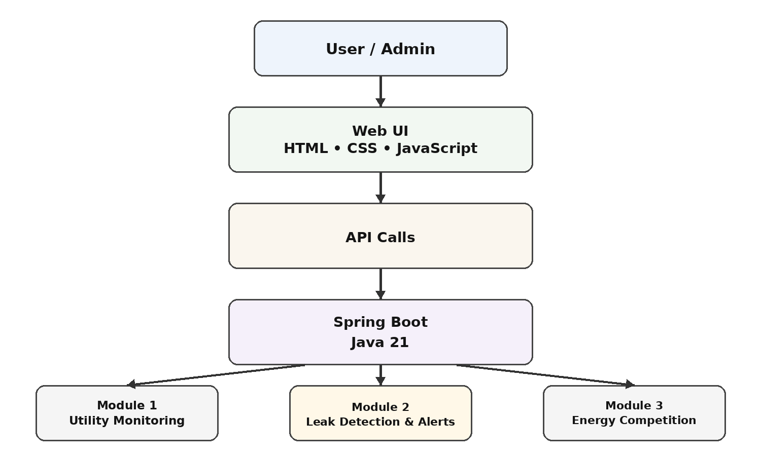
Figure 3.1 Proposed System Architecture
The architecture begins with a user or administrator interacting with the browser interface. JavaScript sends API requests to the Spring Boot backend, where module-specific business logic processes the request and returns validated output for dashboard, alert, ranking or report presentation.
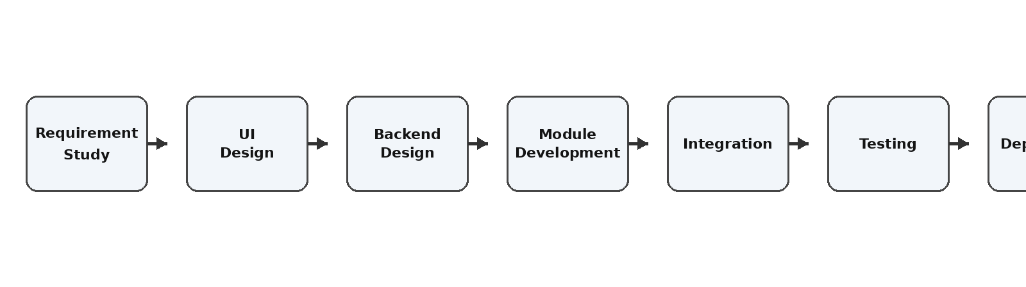
Figure 3.2 System Development Workflow
The workflow follows requirement study, UI design, backend design, module development, integration, testing and deployment. This iterative approach supports progressive validation rather than waiting until the end of implementation to discover integration problems.
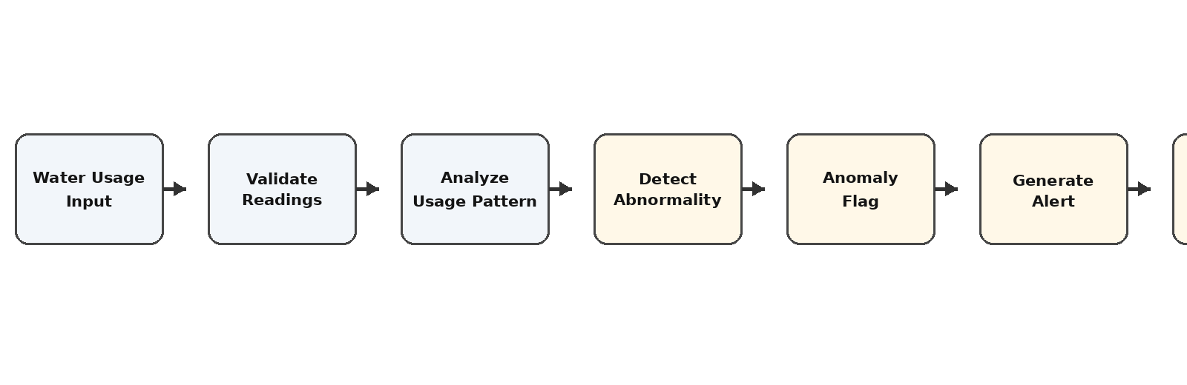
Figure 3.3 Module 2 – Leak Detection & Anomaly Alert Workflow
Module 2 accepts water-usage information, validates the readings, analyses usage patterns and identifies significant abnormal consumption. An anomaly flag is generated and the alert workflow makes the condition visible to the user. IMTHIAZ jointly implemented and tested this module with the teammate.
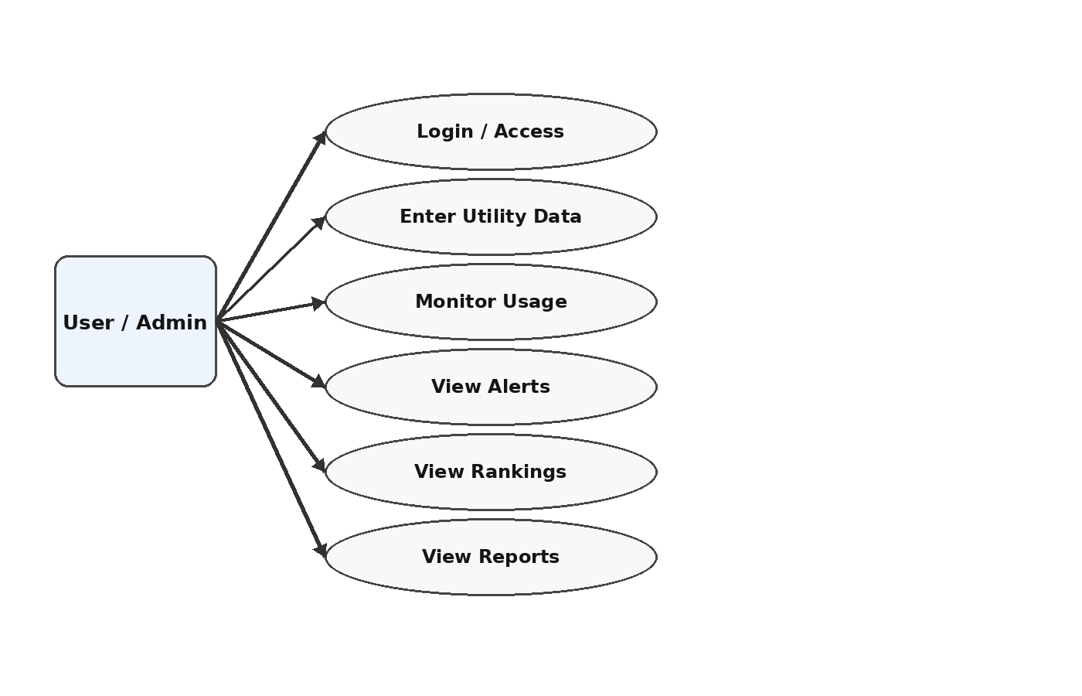
Figure 3.4 Use Case Diagram
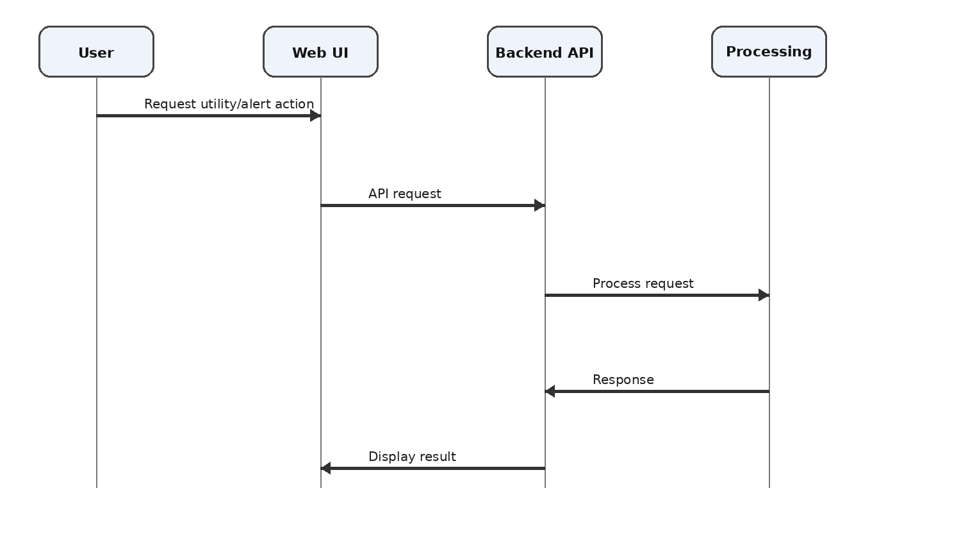
Figure 3.5 Sequence Diagram
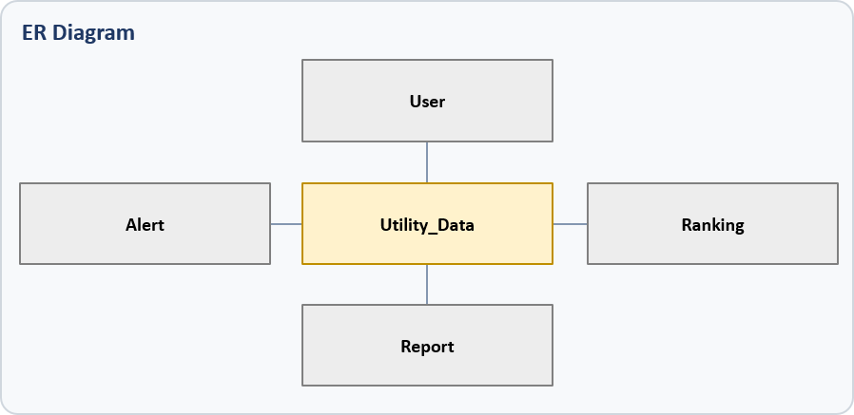
Figure 3.6 Entity / Data Relationship Diagram from Project Prototype
3.6 Trade-off Analysis
Every engineering choice introduces a trade-off. A browser-based system improves accessibility but needs API coordination; pattern-based anomaly detection provides useful automation but depends on the quality of the baseline pattern; and gamified ranking improves visibility of performance but requires a fair and consistent efficiency calculation.
Design Decision | Alternative Considered | Benefit | Disadvantage | Final Decision & Justification
Web UI + Spring Boot backend | Desktop GUI | Central access and modularity | Requires API coordination | Selected because accessibility and separation are improved
Pattern-based anomaly logic | Manual review only | Faster visibility of abnormal water use | Depends on available patterns/thresholds | Selected for timely alerting
Gamified ranking | Simple usage display | Adds comparative engagement | Needs a consistent efficiency indicator | Selected to encourage energy awareness
Prototype without IoT | Immediate sensor integration | Lower hardware complexity | No direct real-time sensing | Selected for current software scope

3.7 Sustainability, Ethics, Safety, Risk & Security
The project supports sustainability by targeting reduced utility wastage and improved energy awareness. Ethical design requires transparent interpretation of alerts and rankings, while safety requires recognizing that a software alert is not a physical leak confirmation. Security considerations include authenticated access and protection of utility information.
Domain | Consideration | Evidence Evaluated | Impact on Final Decision
Sustainability | Reduce avoidable resource wastage | Centralized usage visibility, anomaly alerts and efficiency ranking | Integrated monitoring and engagement retained
Ethics | Avoid misleading alerts or fabricated performance claims | Validation of inputs and explicit project limitations | Results described only within prototype evidence
Health & Safety | Software should not directly control physical infrastructure without validation | Current system is monitoring/alert oriented | Physical control excluded from current scope
Security | Restrict access and protect utility information | Login/access-control concept and backend separation | Access control retained; production hardening identified as future work

Risk | Likelihood | Severity | Risk Level | Mitigation | Residual Risk
Invalid utility input | Medium | Medium | Medium | Input validation and clear data-entry fields | Low–Medium
False anomaly indication | Medium | Medium | Medium | Use expected/pattern-based comparison and validate logic | Medium
Unauthorized access | Medium | High | High | Login/access control; strengthen authentication in production | Medium
API/integration failure | Medium | Medium | Medium | Unit and integration testing | Low–Medium
Insufficient anomaly data | Medium | High | High | Document dependency on available water data; future ML/IoT enhancement | Medium
Deployment/service failure | Low–Medium | Medium | Medium | Centralized deployment and monitoring practices | Low–Medium
CHAPTER 4
IMPLEMENTATION, TESTING & RESULTS, PROJECT MANAGEMENT

4.1 Development Approach & Resources

Development followed an iterative sequence in which requirements and architecture were refined before implementation and integration. This approach made it possible to validate the modules individually and then evaluate the complete UI-to-backend flow.
The project followed an Agile and iterative development approach. Requirement study and UI design were followed by backend design, module development, integration, testing and deployment preparation. Frontend interactions trigger backend API requests, while Spring Boot coordinates module logic and returns processed outputs. The approach supports incremental validation of utility monitoring, anomaly alerts and energy ranking before final integration.

Resource | Purpose
Java 21 | Backend programming language/runtime
Spring Boot 3.3.5 | Application logic and API processing
Maven | Build and dependency management
HTML/CSS/JavaScript | Browser-based user interface
Embedded Apache Tomcat | Application serving
Web browser / development environment | Implementation and validation

4.2 Software Implementation & Modern Tools Used

The implementation uses Java 21 and Spring Boot 3.3.5 for backend logic and API processing, while HTML, CSS and JavaScript provide the browser interface. Maven supports project and dependency management and embedded Apache Tomcat provides the application-serving environment. The separation enables frontend changes without rewriting the core business logic.

Tool / Software / Equipment | Purpose | Stage Used
HTML | Page structure and forms | Frontend development
CSS | Interface styling and layout | Frontend development
JavaScript | Interactions and API calls | Frontend integration
Java 21 | Backend implementation | Backend development
Spring Boot 3.3.5 | REST-style backend and business logic | Backend development
Embedded Apache Tomcat | Serve the application | Deployment/runtime
Maven | Dependencies and build | Build/integration

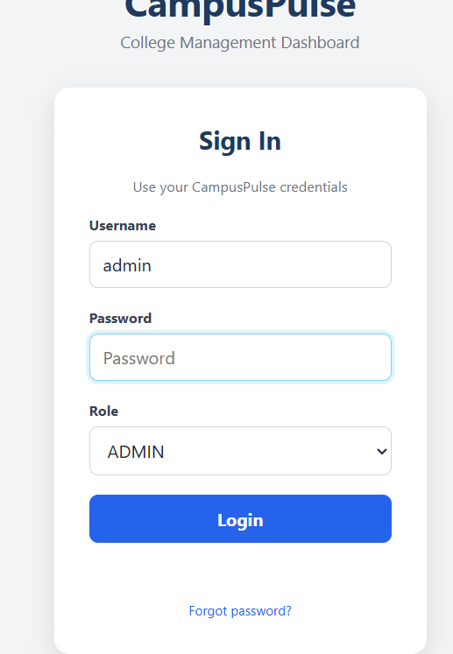
Figure 4.1 Login Interface
The login prototype provides username, password and role selection before access to the administrative application. The interface demonstrates browser-based access and a structured entry point to the system.
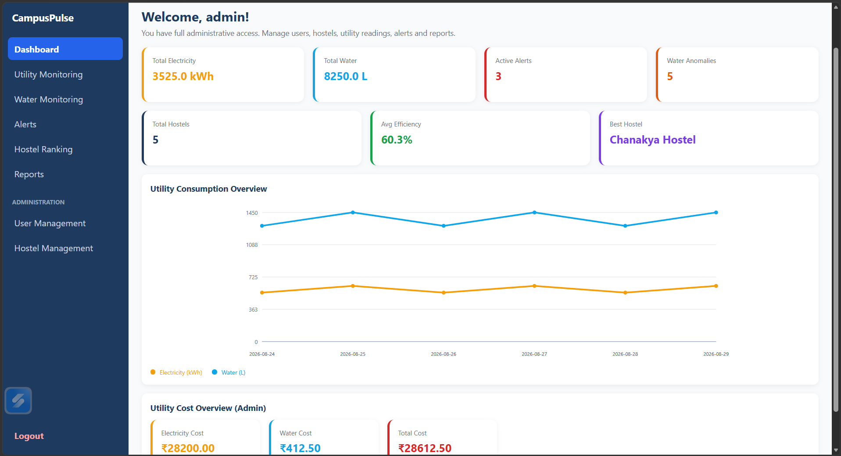
Figure 4.2 Dashboard Interface
The dashboard prototype consolidates key indicators. The displayed prototype shows total electricity of 3525.0 kWh, total water of 8250.0 L, 3 active alerts, 5 water anomalies, 5 hostels, an average efficiency of 60.3%, and Chanakya Hostel as the best hostel. These values are prototype evidence from the supplied project presentation, not a deployment-scale benchmark.
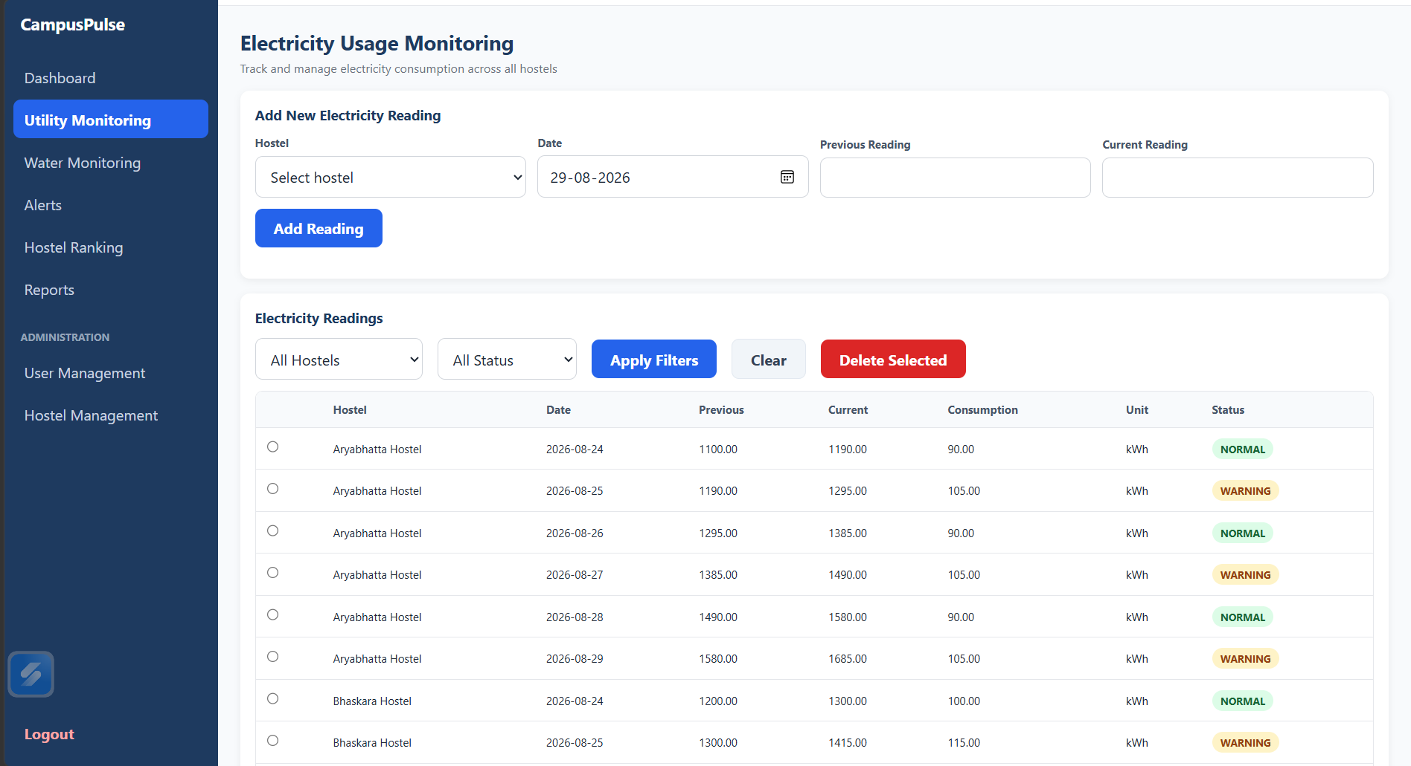
Figure 4.3 Electricity Usage Monitoring Interface

The electricity monitoring interface provides hostel selection, date entry, previous and current readings, filtering and status information. The displayed prototype distinguishes normal and warning records and presents consumption in kWh.
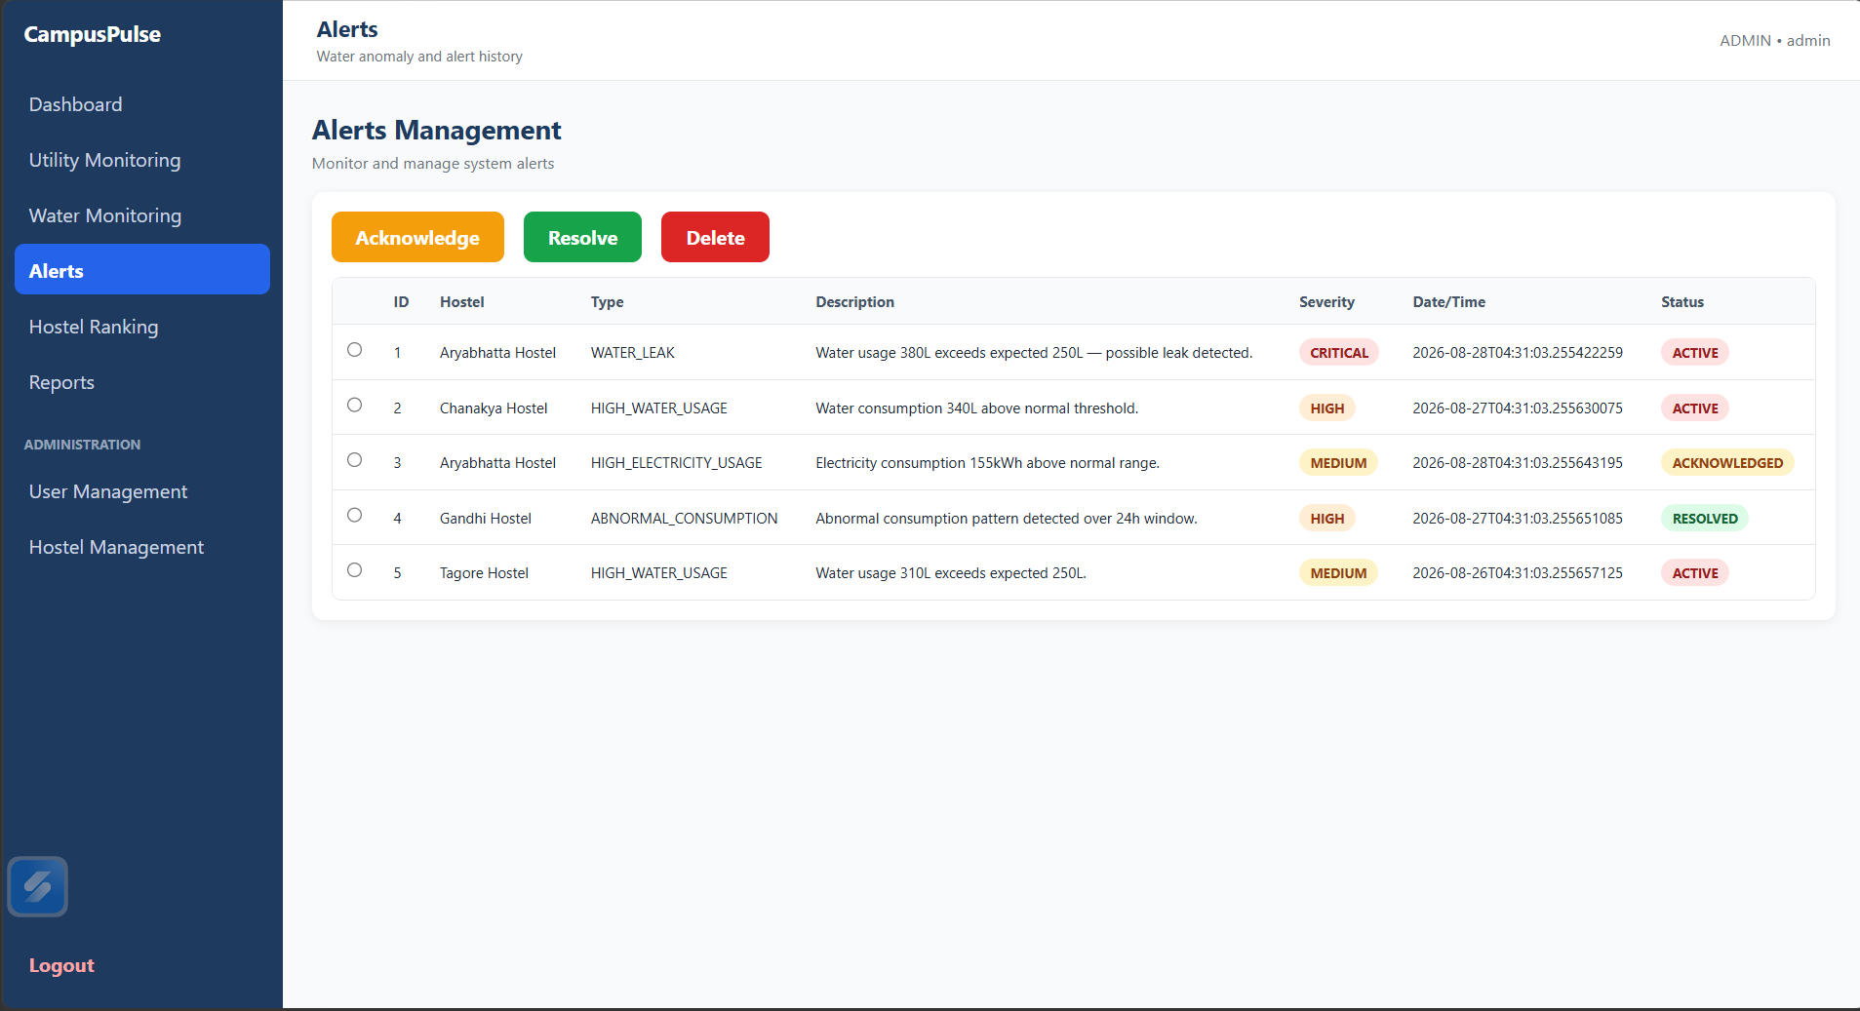
Figure 4.4 Alerts Management Interface

The alert interface demonstrates the output of anomaly and high-usage logic. The prototype includes WATER_LEAK, HIGH_WATER_USAGE, HIGH_ELECTRICITY_USAGE and ABNORMAL_CONSUMPTION examples with severity and status fields. A displayed critical example reports water usage of 380 L against an expected 250 L, indicating possible leakage.
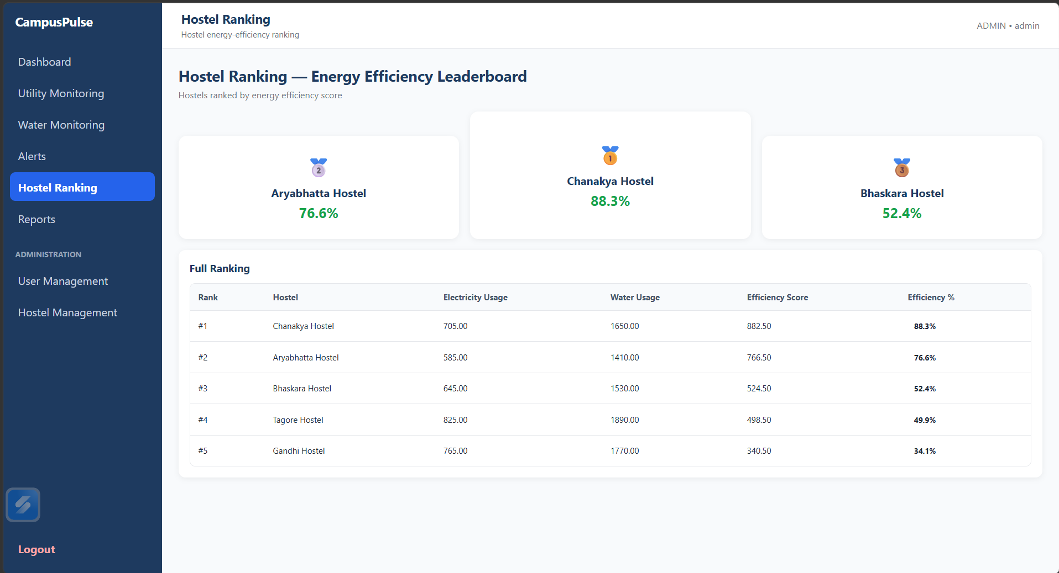
Figure 4.5 Hostel Energy-Efficiency Ranking
The ranking interface demonstrates the gamified energy competition. In the prototype, Chanakya Hostel is ranked first at 88.3%, Aryabhatta Hostel second at 76.6%, Bhaskara Hostel third at 52.4%, Tagore Hostel fourth at 49.9% and Gandhi Hostel fifth at 34.1%.
4.3 Test Plan & Verification
Testing is structured around observable system behaviour. Unit-level checks focus on validation, anomaly logic, efficiency calculation and alert generation, while integration tests verify that a user action can travel from the web interface through the backend and return the correct output. Acceptance criteria are defined before interpreting results.
Requirement | Test Method | Acceptance Criterion
Login/access | Enter valid and invalid credentials/roles | Valid access is accepted; invalid access is rejected
Utility data entry | Submit representative electricity/water readings | Valid records are accepted and displayed
Anomaly detection | Submit/inspect readings above expected pattern | Significant abnormal condition is flagged
Alert generation | Trigger anomaly condition | Alert record contains type, description, severity and status
Energy ranking | Process hostel efficiency information | Hostels are ordered consistently by efficiency
UI/API integration | Perform browser action and trace API response | Expected processed result returns to UI
Dashboard output | Load dashboard with project data | Key totals and indicators are displayed

Specification | Required Value | Achieved Value | Status (Pass/Fail)
Dashboard resource summary | Display electricity and water totals | Prototype displays 3525.0 kWh and 8250.0 L | Pass
Active alert visibility | Display active alerts | Prototype displays 3 active alerts | Pass
Water anomaly visibility | Display anomaly count | Prototype displays 5 water anomalies | Pass
Ranking output | Display ordered hostel efficiencies | Prototype shows five-hostel ranking | Pass
Alert severity/status | Show severity and lifecycle status | Prototype shows critical/high/medium and active/acknowledged/resolved | Pass
Deployment-scale benchmark | Measured quantitative benchmark | Not provided in PPT | Not evaluated

4.4 Results
The available project evidence demonstrates the intended functional flow of the integrated design. Utility information can be represented through centralized monitoring, abnormal water-use conditions can be surfaced as alerts, and energy information can be converted into comparative rankings. Quantitative performance claims are intentionally limited because the PPT identifies final execution/testing as the point at which benchmark values can be added.

Result Area | Prototype Evidence
Centralized utility monitoring | Dashboard and electricity monitoring interfaces show utility values and status
Water anomaly detection | Alerts interface shows WATER_LEAK, HIGH_WATER_USAGE and ABNORMAL_CONSUMPTION records
Alert lifecycle | Prototype includes Active, Acknowledged and Resolved statuses
Energy competition | Ranking interface presents five hostel efficiency percentages
Dashboard summary | Shows electricity, water, active alerts, anomalies, hostel count and average efficiency
Web migration benefit | Browser UI is separated from Spring Boot backend logic

The prototype demonstrates the intended functional outputs. However, the supplied project material explicitly notes that quantitative performance benchmarking should be added after final execution/testing. Therefore, this report does not claim response-time, accuracy or large-scale performance values that are not evidenced in the source material.
4.5 Data Analysis & Engineering Judgment
Engineering judgment is particularly important in Module 2 because an anomaly is an indication rather than proof of a physical leak. The system therefore emphasizes visibility and investigation support. A future implementation with calibrated sensors and larger historical datasets could improve confidence in the anomaly decision.
The dashboard evidence indicates that the system can consolidate multiple resource indicators into a single administrative view. The alert evidence shows that abnormal water usage can be surfaced with severity and status information, making the anomaly output more actionable than a raw usage table. The ranking evidence shows that the energy-efficiency indicator can be transformed into an ordered comparison across hostel blocks.

For Module 2, the engineering judgment is that anomaly detection should remain separated from presentation. Water-usage analysis produces an anomaly state, while the alert interface handles visibility and status. This separation makes the module easier to validate and allows future replacement of the current pattern/threshold logic with more advanced analytics without redesigning the entire UI.
The main data limitation is that anomaly accuracy depends on the available water-usage readings and the detection logic. The project therefore treats IoT data acquisition and machine-learning-based anomaly detection as future improvements rather than claiming that the current prototype provides production-grade prediction accuracy

4.6 Comparison with Existing Solutions & Achievement of Objectives
The proposed application improves integration by placing utility monitoring, anomaly alerts and energy comparison in one web environment. Objective achievement should be interpreted from the available functional evidence and final execution results rather than from unsupported numerical performance claims.
Objective | Evidence | Achievement
Centralized web architecture | Browser UI + Spring Boot backend architecture | Fully Achieved
Electricity and water monitoring | Dashboard and utility monitoring interfaces | Fully Achieved
Water anomaly identification | Alerts interface and Module 2 workflow | Fully Achieved
Alert generation | Alert records with type, severity and status | Fully Achieved
Energy-efficiency comparison | Hostel ranking interface | Fully Achieved
Testing and validation | Test plan and prototype evidence | Partially Achieved
Quantitative performance benchmarking | Not available in PPT | Not Achieved / Future Validation

4.7 Strengths & Limitations
The main strengths are modularity, centralized access, integrated monitoring and the addition of automated anomaly indication and energy ranking. The main limitations are data dependence, absence of direct IoT sensing in the current scope and the need for further security and scalability work before production deployment.
Strengths:
Integrated three-module design in one web application.
Centralized browser-based utility visibility.
Dedicated water anomaly and alert workflow.
Gamified hostel ranking for energy awareness.
Frontend/backend separation improves maintainability.
Clear future path for IoT, machine learning and notifications.
Limitations:
Current scope is limited to the defined three software modules.
Anomaly accuracy depends on available water-usage data and detection logic.
Real-time IoT sensor integration is outside the current prototype.
Deployment-scale quantitative benchmarking remains to be performed.
Production deployment would require stronger authentication, monitoring and security hardening.

4.8 Project Planning, Roles & Budget
Project progress was organized through identifiable milestones from problem identification to deployment and documentation. Responsibilities were separated by module while selected activities, especially Module 3, integration and review preparation, were completed jointly. The budget represents prototype development resources and should be updated with actual purchase values where available.

Milestone | Status
Problem Identification | Completed
Review-1 Feedback Analysis | Completed
Three-Module Architecture | Completed
UML / Database Planning | Completed
Desktop → Web Architecture Change | Completed
Frontend Development | Implemented / In Progress at review stage
Spring Boot Backend | Implemented / In Progress at review stage
Full Integration & Validation | Final Stage
Deployment & Documentation | Final Stage

Student | Assigned Responsibility | Actual Contribution
IMTHIAZ | Module 2 – Leak Detection & Anomaly Alert; joint work with teammate | Joint design, anomaly logic, alert workflow, testing/validation and related documentation
G SAI DEEPAK (19231142) | Module 2 joint work plus web application/frontend/backend support | Joint Module 2 development, integration, testing and documentation

Item | Estimated Cost | Actual Cost
Software tools / frameworks | No separate project-specific cost identified | Not separately recorded
Hardware / sensors | Outside current prototype scope | Not incurred in current prototype
Development environment | Existing computing environment | Not separately recorded
Total | To be verified from institutional records | To be verified

CHAPTER 5
CONCLUSION, FUTURE WORK AND REFLECTION

5.1 Conclusion

The Cross-Utility Smart Campus Resource Monitor: Integrated Energy Competition and Water Leakage Detection provides a software-based approach for monitoring campus utility usage and identifying abnormal water-consumption conditions. The system is developed using a web-based frontend with HTML, CSS, and JavaScript, together with a backend implemented using Java 21 and Spring Boot 3.3.5.
The major individual technical contribution presented in this report is Module 2: Leak Detection & Anomaly Alert. The module was designed to analyse water-consumption information and identify significant deviations from expected usage conditions. The implemented approach processes water-usage values, evaluates abnormal conditions, generates anomaly flags, and produces suitable alerts.
The module provides a structured workflow consisting of:
Water-Usage Data → Data Processing → Expected Usage Comparison → Anomaly Detection → Anomaly Flag → Alert Generation
The implementation demonstrates how Java-based application logic can be used to convert water-consumption information into meaningful monitoring information. Conditions such as WATER_LEAK, HIGH_WATER_USAGE, and ABNORMAL_CONSUMPTION can be represented through the alert mechanism, allowing abnormal usage conditions to be identified more clearly.
Testing with normal and abnormal water-usage scenarios helps verify the behaviour of the anomaly-detection and alert-generation processes. The module therefore provides a practical software foundation for identifying possible water wastage and supporting timely monitoring within a smart campus environment.
Overall, the Leak Detection & Anomaly Alert Module contributes to efficient resource management by reducing dependence on manual inspection and providing systematic identification of unusual water-consumption conditions.

5.2 Future Work
The module can be further improved through the following enhancements:
- Integration with real-time water-flow sensors for continuous consumption monitoring.
- Development of more advanced anomaly-detection algorithms.
- Use of historical water-usage data to establish adaptive consumption patterns.
- Implementation of machine-learning-based leakage prediction.
- Addition of real-time notifications through email or mobile applications.
- Development of configurable thresholds for different campus locations.
- Addition of historical anomaly and alert analysis.
- Development of graphical water-consumption trends.
- Integration with IoT devices for continuous data transmission.
- Improvement of false-positive and false-negative detection handling.
- Addition of automatic alert-priority classification.
- Extension of the system to support multiple water-monitoring points.
- Implementation of improved authentication and role-based access control.
- Optimization of backend processing for larger volumes of water-consumption data.
These improvements can make the module more adaptive, accurate, scalable, and suitable for real-world smart-campus deployment.

5.3 Individual Reflection

IMTHIAZ (192521360)
My individual contribution to the Cross-Utility Smart Campus Resource Monitor focused on Module 2: Leak Detection & Anomaly Alert. My primary responsibility was to design and implement the software workflow required to analyse water-consumption information and identify abnormal usage conditions.
During the development of the module, I worked on the processing of water-usage information, comparison of actual and expected consumption, anomaly identification, anomaly flag generation, and alert-generation logic. I also worked on testing the module using different normal and abnormal water-consumption scenarios to verify that the implemented logic produced appropriate results.
This module helped me improve my practical understanding of Java programming and Spring Boot application development. I gained experience in implementing application logic, handling data-processing conditions, designing anomaly-detection workflows, and integrating the resulting information into a larger software system.
I also understood that an anomaly-detection system must balance detection sensitivity and reliability. If the detection conditions are too sensitive, unnecessary alerts may be generated, while conditions that are too relaxed may cause important abnormal events to be missed. Therefore, testing and refinement are important parts of developing a reliable monitoring module.
Through this project, I gained practical knowledge of how software engineering can be applied to resource monitoring and sustainable water management. The development experience also improved my understanding of problem analysis, modular design, testing, debugging, documentation, and systematic engineering decision-making.
Overall, working on Module 2 provided valuable experience in developing a practical Java-based monitoring solution and helped me understand how automated anomaly detection can support efficient resource utilization in a smart campus environment.

REFERENCES

[1] Spring Boot, “Spring Boot Reference Documentation,” Spring project documentation.
[2] Oracle, “Java Platform, Standard Edition 21 Documentation,” Java SE documentation.
[3] Apache Software Foundation, “Apache Maven Documentation,” Maven project documentation.
[4] Web platform documentation, “HTML, CSS and JavaScript documentation,” standard web-development reference material.
[5] Project PPT, “Cross-Utility Smart Campus Resource Monitor: Integrated Energy Competition and Water Leakage Detection,” Team 13 project presentation, 2026.
[6] Capstone Project Report Format, SIMATS Engineering, Saveetha Institute of Medical and Technical Sciences, 2026.
The report follows a consistent IEEE-style numbered reference convention. Specific publication details are not fabricated where the supplied project presentation does not provide them.

APPENDICES

Appendix A – Detailed Calculations
The project PPT describes the anomaly logic as comparing incoming water usage with expected or previously established patterns and flagging significant abnormal consumption. The exact production threshold formula and deployment-scale statistical calculations are not specified in the source material and therefore require final implementation evidence before being reported as quantitative equations.
Appendix B – Engineering Drawings / Schematics

Appendix Figure B.2 – Module 2 Workflow
Water-Usage Data → Data Processing → Expected Usage Comparison → Anomaly Detection → Anomaly Flag → Alert Generation → Monitoring / Corrective Action

Appendix C – Source Code / Code Repository Information
Project repository reported in the PPT: https://github.com/Imthiaz-123/campuspulse123
Live deployment reported in the PPT: https://campuspulse123.onrender.com
Only essential code excerpts should be included in the final institutional report. The complete source code can be maintained in the approved repository.

Appendix D – Datasheets
Not applicable to the current software-only prototype; no physical sensors or hardware datasheets are included in the project scope.

Appendix E – Experimental / Raw Data
Prototype evidence is represented by the dashboard, utility monitoring, alert and ranking screenshots included in Chapter 4. A separate deployment-scale raw dataset was not supplied with the PPT.

Appendix F – Ethics / Institutional Approval
No separate institutional approval artifact is identified in the supplied project material. Insert approval documentation here if required by the department.

Appendix G – Project Meeting / Progress Records
Project milestone evidence is summarized in Chapter 4.8. Insert signed meeting/progress records here if required.

Appendix H – User / Industry Feedback
No formal user/industry feedback document is identified in the supplied project material. Insert evidence if available.

Appendix I – Publications / Patents / Competitions / Product Outcomes
No publication, patent or competition outcome is identified in the supplied project material.

Appendix J – Individual Contribution Evidence
IMTHIAZ – Module 2: Leak Detection & Anomaly Alert, jointly developed with teammate. Evidence includes the Module 2 workflow, alert interface, anomaly logic description, testing plan and related implementation/documentation sections in this report.

CAPSTONE PROJECT OUTCOME MAPPING SHEET

To be completed by the department/faculty assessor.

Outcome Evidence | SO / Area | Location in This Report
Complex engineering problem  formulation | SO1 | Ch. 1, Ch. 2
Engineering design under constraints | SO2 | Ch. 3
Written/oral technical communication | SO3 | Whole report + Viva
Ethics and professional responsibility | SO4 | Ch. 3 (3.7)
Teamwork and leadership | SO5 | Ch. 4 (4.8)
Experimentation, analysis, engineering  judgment | SO6 | Ch. 4 (4.3–4.6)
Independent acquisition of new  knowledge | SO7 | Ch. 5 (5.3)
Standards | SO2 | Ch. 3 (3.2)
Sustainability and  societal/environmental impact | SO2/SO4 | Ch. 3 (3.7)
Risk assessment and mitigation | SO2/SO4 | Ch. 3 (3.7)
Security considerations | Relevant SO | Ch. 3 (3.7)
Integrated/system-level engineering | SO1/SO2 | Ch. 3 (3.5)
Project planning and management | SO5 | Ch. 4 (4.8)
Individual contribution | SO1–SO7 | Contribution Statement + Ch. 4  (4.8)

